**Magento Checkbook Extension (Installation Guide)**

Attached zip (cedcoss_checkbook.zip) contains two folders named app & js. Simply Extract these two folders within magento root directory (Your root directory on server contains the folder app, design, var etc.) Just paste those app and js folder within this root dir. Make sure you merge the app and js folders from the zip file in the existing app and js folders in the app root folder. After extracting files, log in to your admin panel and go to **System-> Configuration-> Payment Method**

By clicking the tab ‘Checkbook Payment’ you can configure the ‘Checkbook API Extension’ (refer the screenshot given below.)

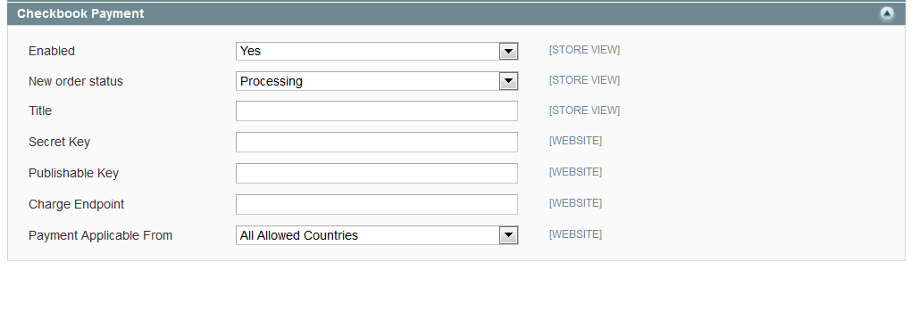

If you can not find that tab or get any 404 error or Access Denied message (during first time installation) then please try following steps:

1. Log out the admin session and then login and check once again.
2. Go to ‘Admin->System-Cache Management’ and click on ‘Flush Magento Cache’ and check it again.

Below are the fields which must be filled from backend.

**Enabled** -> ‘Yes’ (Don’t forget to enable this option.)

**New Order Status** -> You can set the new order status from here. (What I set is ‘processing’). Means when user creates order with thins payment option order will get this status.

**Title** -> Set the title from here (It will show under payment information on checkout page.)

(What I set here is ‘Pay By Checkbook’)

**Secret Key** -> Paste your ‘secret key’ here which you got from ‘checkbook.io’

(e.g.: C4WCmvYHCKFmMV0jHYQC792XEaSE9L6rfUWfyI3vP1o)

**Publishable Key** -> Paste your ‘publishable key’ here which you got from ‘checkbook.io’

(e.g.: MJ95Gjr9G6wBKwBiPbYG9JavvGnG4lnyC6QSZt9G8Ag)

**Charge Endpoint** (Production ) -> This is the API charge point URL.( <https://www.checkbook.io/api/charge>)

**Charge Endpoint** (sandbox ) -> This is the API charge point URL.( <https://sandbox.checkbook.io/api/charge>)

**Important code updates:**

1. In: Checkbook_Checkbook / app / design / frontend / base / default / template / checkbook / form.phtml

Find the variable: “checkbook_config” and replace values for these variables with your company name: “data_name” and “data_for”.

2. In the same config, completely remove line with “data_env : "sandbox"” when you want to start hitting production API, which will enable live transactions

Now after saving these settings you should find a new payment option on front-end checkout page:

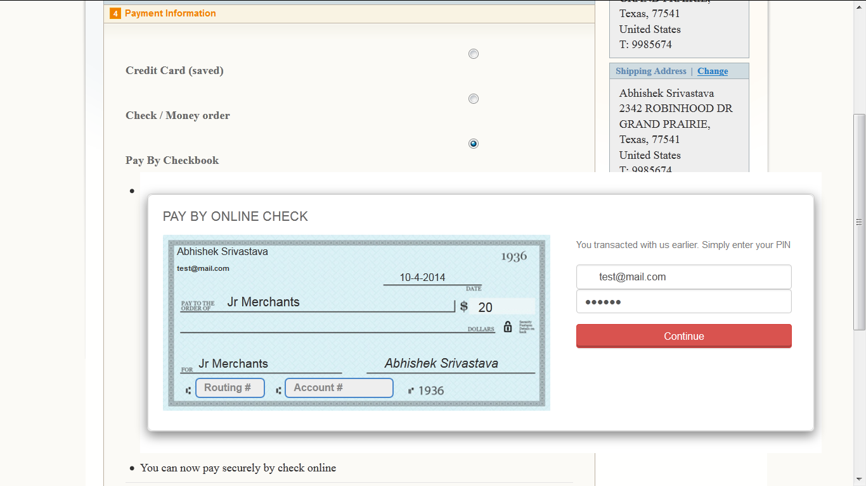

After you submit your order, you should get ‘Success Message’ response from the back-end. If not you’ll see an ’An error message’ - if so please diagnose accordingly or get in touch with our support email.

Success Message:

